**4) Data collected/to be collected**

We used Go-pro camera (Hero 4) with high-definition resolution 1920x1080.

The first training data were captured near campus (Fifth & Forbes) as shown in the following map.

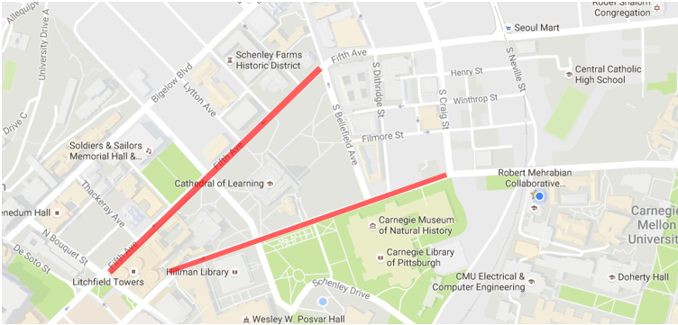

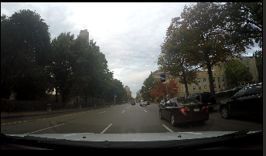 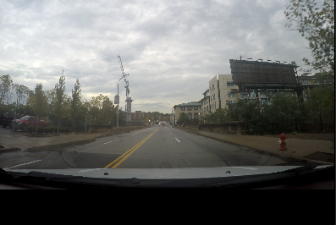 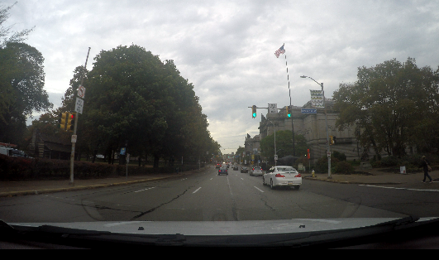

**6) Time line (Tasks completed so far AND tasks to be completed)**